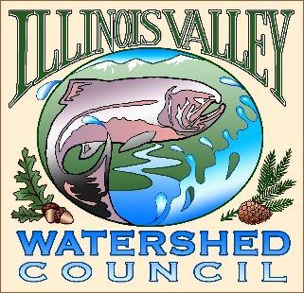 | Illinois Valley Watershed Council  331 E Cottage Park Suite 1B - P.O. Box 352  Cave Junction, OR 97523  Phone: 541-592-3731

Bi-Monthly Council Meeting Agenda

March 25, 2021 IVWC Office/ZOOM

- 6:00 PM: Call to Order
- 6:05 PM: Acceptance of Minutes

- 6:15 PM: Acceptance of Financial Reports

- 6:30 PM: Old Business
  - New Office
  - OWEB Fire Response Grant Update
  - Website Update

- 6:45 PM: New Business
Action Items-
  - Applications for Council Director
  - Four Way Community Foundation Grant

- 7:00 PM: Council Updates & Staff Reports
  - Kevin report
  - Arlyse report

- 7:15 PM: Public Comments (Relating to this agenda or IVWC Operations)

- 7:30 PM: Adjournment

