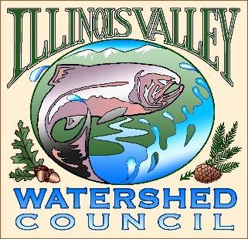 | Illinois Valley Watershed Council  331 E Cottage Park Suite 1B - P.O. Box 352  Cave Junction, OR 97523  Phone: 541-592-3731

Monthly Council Meeting Agenda

June 23,2022 IVWC Office/ZOOM

Times are approximate- meeting to follow IVSWCD Meeting
- 7:30 PM: Call to Order
- 7:35 PM: Acceptance of Minutes

- 7:40 PM: Acceptance of Financial Reports

- 7:45 PM: Old Business
  - Strategic Planning Update
  - Water Quality

- 8:00 PM: New Business
  - Employee Wage review
  - Page Creek Project Update
  - Payroll Options Quote

- 8:15 PM: Council Updates & Staff Reports
  - Kevin report
  - Arlyse report

- 8:30 PM: Public Comments (Relating to this agenda or IVWC Operations)

- 8:45 PM: Adjournment

