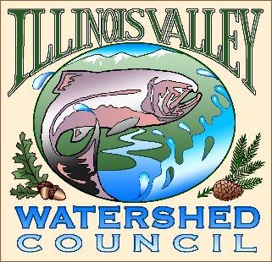 | Illinois Valley Watershed Council  331 E Cottage Park Suite 1B - P.O. Box 352  Cave Junction, OR 97523  Phone: 541-592-3731

Monthly Council Meeting Agenda

March 14, 2023

- 5:00 PM: Call to Order
- 5:02 PM: Acceptance of Minutes
- 5:05 PM: Acceptance of Financial Reports
- Committee Reports
  - Programs and projects- no report required.
  - Budget- no report required.
  - Human Resources
  - Organizational Development
  - Policy

- 5:25 PM: Old Business
  - Treasurer replacement?
  - Conflict of Interest Policy
  - Tabled proposals

- 5:50 PM: New Business
  - The Big Picture

- 6:00 Strategic Plan Check-In
  - Review of actions completed.

- 6:15 PM: Council Updates & Staff Reports
  - Kevin report
  - Arlyse report

- 6:30 PM Partnering Agency Reports
  - Illinois Valley SWCD
  - Others

- 6:45 PM: Public Comments (Relating to this agenda or IVWC Operations)

- 7:00 PM: Adjournment

