Illinois Valley Watershed Council
Strategic Plan – 2024-2026

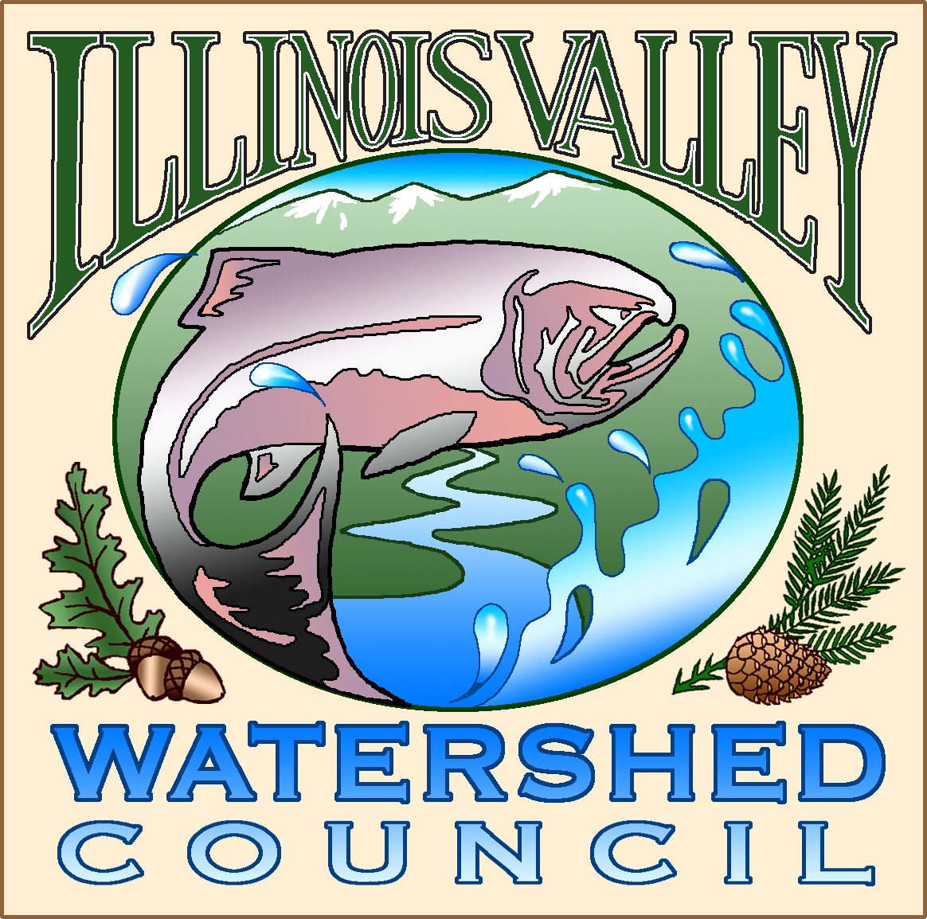

Illinois Valley Watershed Council – Strategic Plan 2024-2026

Executive Summary
The Illinois Valley Watershed Council (IVWC) plays a crucial role in watershed management policy and projects for residents and community partners in the Illinois Valley (IV). As such, it’s critical that the actions of IVWC are guided by a consensus-based Strategic Plan that considers the concerns and needs of the residents of the Illinois Valley. Given the varying and often conflicting needs and desires of farmers, ranchers, outdoor enthusiasts, and others, this plan was developed by reviewing history, discussing key issues and perspectives, and considering an array of activities that will lead to improving and sustaining the health of the Illinois Valley watershed for generations to come.

This project commenced in earnest during the summer of 2023 with interviews of key IVWC and IVSWCD Members. We followed with three half day working sessions during which we framed and formed the plan. The plan, revised bylaws and summaries of community partner interviews were presented and adopted by the IVWC Board on January 11, 2024.

After settling on a revised Mission, Vision, Core Values and Value Statement the team proceeded to develop a detailed 3-Year Action Plan in the follow Goal Areas:

Governance and Operational Capacity – Including by-law updates, capacity building funding initiatives and operating guidelines.

Watershed Health Programs and Projects -- Including development of a Watershed Project Plan, guidelines around project selection and execution of specific, high priority projects. Also includes partnering parameters with other key agencies, organizations, and stakeholders.

Community, Partners, and Neighbor Engagement – Including securing funding and finding a staffing resource to focus on community outreach program development and execution. Programs will include community and school education events and forums. Efforts will also include development and updating of informational content, web site updates, social media updates and postings and related efforts as they are identified.
Introduction
The Illinois Valley Watershed Council (IVWC) plays a crucial role in watershed management policy and projects for residents and community partners in the Illinois Valley (IV). As such, it’s critical that the actions of IVWC are guided by a consensus-based Strategic Plan that considers the concerns and needs of the residents of the Illinois Valley. Given the varying and often conflicting needs and desires of farmers, ranchers, outdoor enthusiasts, and others, this plan was developed by reviewing history, discussing key issues and perspectives, and considering an array of activities that will lead to improving and sustaining the health of the Illinois Valley watershed for generations to come.

This plan has specific Goals, Objectives, and Key Performance Indicators (KPIs) which are solidly anchored to the foundation of the Mission and Vision of IVWC as it is clarified or redefined in this process.

Working Team
Katrina Poydack Chair
Patricia Downing Secretary
Gene Merrill Treasurer
Carol Crawford Director
Janice Denney Director
Jim Gurley Director
Bob Schmidt Director
Don Young Director
Kevin O’Brien Watershed Coordinator/Executive Director
Arlyse DeLoyola Office Manager
Bob Webb
Rob Hambleton Soul Canyon Training & Development – Consultant & Facilitator

Working Process
This project commenced in earnest during the summer of 2023 with interviews of key IVWC and IVSWCD Members. We followed with three half day working sessions during which we framed and formed the plan. The plan, revised bylaws and summaries of community partner interviews were presented and adopted by the IVWC Board on January 11, 2024.

Illinois Valley Watershed Council – Strategic Plan 2024-2026

Mission Statement
We collaborate with our community to restore, enhance, and sustain the health of the Illinois Valley Watershed. Water is life and healthy watersheds sustain life.
IVWC Core Values – We Value….
- Data and science driven information and processes.
- Knowledge, communication, learning and teaching.
- Collaboration.
- Community engagement.
- Proven processes.
- Measured progress.
- Acknowledgement that all parts of the watershed are connected and interdependent.
- Respectfulness.
- An inclusive community.
- Openness, honesty, and transparency.

Value Statement
“We acknowledge that the previous indigenous cultures that have existed for thousands of years, practiced humility and respect for this great matrix, our Earth, this place.

We hope that we can return to the practice of humility and respect for our earth, so that “restore, enhance and sustain” will take their rightful place as the natural outflows of a healthy, thriving, living earth system.

We believe that the council is engaged in a sacred and ancient trust by acting as guardians for the great matrix of interdependent life we call Earth. We as humans are an extremely small part of that matrix. Our pledge and mission is to “restore, enhance and sustain” and is necessary because of our culture’s actions.”

3 Year Vision
We are a vibrant and healthy organization that is well funded and engages in projects that restore, enhance, and sustain the health of the Illinois Valley Watershed. We are respected and integrated with our community and conduct training and events that inform our community about the importance of watershed health.

Goals and Objectives
To activate the IVWC Mission and Vision we have developed goals and objectives in the following three areas to be monitored, adjusted, and achieved between now and the end of 2026:

Goal Areas
- Governance and Operational Capacity
- Watershed Health Programs and Projects
- Community, Partners, and Neighbor Engagement

Illinois Valley Watershed Council – Strategic Plan 2024-2026

2024 Goals – Governance and Operational Capacity

Q4 2023 – Q1 2024
- Add a regular meeting agenda item regarding performance to Strategic Plan.
- Finalize updated By-Laws.
- Begin reviewing, changing, and adding policies.
- Make all By-Laws and Policies accessible both in-office and on the website.
- Identify and populate committees.
- Create a fundraising plan.
- Create a Director’s duties and responsibilities guidelines document.
Q2-Q3 2024
- Determine how to separate the Coordinator’s job into logical pieces and get them funded, creating the position of Executive Director.
Q4 2024
- Write and finalize job descriptions and Standard Operating Procedures (SOPs)
- Develop a succession plan for Executive Director.
- Expand our funding partner base by securing a partnership with at least one new funder or funding initiative.
2025
- Develop a Watershed Action Plan that directs restoration project strategy.
- Review, refine and assess impact of 2024 activities.
- Expand our funding partner base by securing a partnership with at least one new funder or funding initiative.
2026
- Recruit, select, and onboard replacement for IVWC ED.
- Expand our funding partner base by securing a partnership with at least one new funder or funding initiative.

Illinois Valley Watershed Council – Strategic Plan 2024-2026

2024 Goals – Watershed Health Programs & Projects

By the end of 2024 we will…….
- Implement Crooks Ck LWM Project – Phase 2.
- Implement East Fork – Mendoza Habitat Enhancement Project – Phase 1.
- Complete designs for IV Country Club Restoration Project and apply for implementation funding.
- Locate and secure funding for launching our passive WQM partnership with the US Geological Survey.
- Implement Horse Creek Culvert Replacement Project.
- Complete FS 1) Habitat Surveys and 2) Fish Presence and Abundance Surveys.
- Strategically engage with landowners adjacent to Crooks Creek and East Fork – Mendoza project areas.
- Have established dialogue with Josephine County to develop a framework for IVWC to help with handling illegal cannabis grow properties; and,
Q4 2023 – Q1 2024
- Perform No-Rise Floodplain Analysis for EFk-Mendoza.
- Identify and apply for regulatory permits for EFk-Mendoza.
- Oversee regulatory permit confirmations for Crooks Creek.
- Apply and/or collaborate for leverage funding and in-kind materials (LWM) for EFk-Mendoza.
- Identify and apply for funding for launching our Passive WQM project.
- Administer service contract for FS-funded winter fish presence and abundance surveys; and,
- Publish Cannabis Post-Cultivation Site Assessment Guide.
Q2 2024
- Regulatory permit follow-through for EFk-Mendoza and Crooks Creek projects.
- Targeted outreach to landowners adjacent to current projects.
- Contract administration for Horse Creek Culvert Replacement project.
- Contract administration for Crooks Creek LWM project.
- Apply to OWEB for Passive WQM project.
- Start Josephine County meetings.

2024 Goals – Watershed Health Programs & Projects (Continued)

Q3 2024
- Contract administration for EFk-Mendoza Project.
- Implement Crooks Ck LWM project – Phase 2, Horse Ck Culvert Replacement project, EFk-Mendoza project – Phase 1.
- Administer service contract for habitat surveys (FS-funded).
- Quality Assurance for IV Country Club Project.
Q4 2024
- Apply to OWEB Restoration Program during Fall Open Cycle (October) for various projects (Crooks Ck, EFk-Mendoza, Others TBD).
- Project Completion Reporting.
- ID and apply to non-OWEB restoration funding sources.
- Targeted outreach to landowners adjacent to current projects.
- Establish project identification and evaluation policy and implementation of the Programs Committee.
2025
- Continue integrating the Programs Committee.
- Apply to OWEB during their Spring (for TA asks) and Fall (for Restoration asks) Open Cycles as appropriate.
- Develop and implement EFk-Mendoza – Phase 2.
- Develop and implement Crooks Creek – Phase 3.
- Expand the passive WQM program.
- Establish a formal partnership with Josephine County that defines and establishes roles and responsibilities for handling illegal cannabis grow properties.
2026
- Apply to OWEB during their Spring (for TA asks) and Fall (for Restoration asks) Open Cycles as appropriate.
- Develop and implement EFk-Mendoza – Phase 3.
- Develop restoration projects in the Deer Creek Watershed.
- Expand the passive WQM program.
- Further cultivate Josephine County partnership to expand into reconsidering the existing riparian setback ordinance.

Illinois Valley Watershed Council – Strategic Plan 2024-2026

2024 Goals – Community, Partners, and Neighbor Engagement

By the end of 2024 we will….
- Establish and launch the Community Partners Engagement Program.
- Clearly establish why it is vital for IVWC to engage with the community and partners.
- Secure funding to support a part-time Program Coordinator.
- Secure the services of a part-time Program Coordinator.
- Start identifying and prioritizing who we are going to engage with: i.e., which regions/sectors/demographics/etc. Are we wanting or needing to target engagement projects?
- Start identifying how we are going to engage and with what messaging.
- Identify, develop, and launch at least two engagement projects.
- Benchmark communications and outreach efforts of other Southern Oregon Watershed Councils.
Q4 2023 – Q1 2024
- Interview key community partners (e.g. IVCDO, City of CJ, USFS, BLM, etc.) about how IVWC can be a better partner.
- Committee forms and begins meeting.
- Potential community partners are identified for inclusion in committee service.
- The capacity funding hunt for the program coordinator position begins.
- Develop evaluation criteria for application and funding program suitability.
- Start identifying potential funding partners or programs.
- Cultivate relationships with potential funders.
- Start applying for capacity funding.
- Develop Program Coordinator job description.
- Launch and start using fundraising software on IVWC website (first “event”).
- Contact and meet with two other watershed councils to discuss outreach programs.

2024 Goals – Community, Partners, and Neighbor Engagement (Continued)

Q2 2024
- Recruit potential community partners for inclusion in committee service. Identify vehicles for outreach (website, social media, newspaper, personal outreach).
- Continue refining and implementing appropriate capacity funding hunt tasks from Q1 (especially applying for and securing smallish grants!)
- Determine the minimum funding threshold that will trigger advertising and recruitment for the Program Coordinator position.
- Fully execute agreements for any early grant awards secured.
- Begin advertising/recruiting for Program Coordinator.
- Establish applicant evaluation criteria/values.
Q3 2024
- Select and onboard the new part-time Program Coordinator.
- Start building “Customer Relationship Management” (CRM) database.
- Host an open house/community partners watershed party (second “event”).
- Begin frequently updating social media platforms.
- Program Coordinator develops annual work plan.
- Begin the discovery process for multi-year funding initiatives that will provide program stability and sustainability (e.g., Meyer Memorial Trust, others)
Q4 2024
- Apply for OWEB Engagement Program Grant funding.
- Submit grant proposals to suitable multi-year program funding sources.
- Document and report on program achievements.
2025
- Develop a Community Partners Engagement Plan (Q1 & Q2).
- Launch a program newsletter.
- Engage, engage, engage.
- Locate and secure program funding.
- Launch a program column in the IV news; and,
- Begin implementing the engagement plan (Q3 & Q4).
2026
- Locate and secure program funding.
- Continue implementing the engagement plan established in 2025.
2024 Goals – Community, Partners, and Neighbor Engagement (Continued)
Community Partner Interviews
Summary
To gain some valuable input to the IVWC Strategic Plan, I conducted interviews with key area leaders and professionals who have a vested interest in the overall economic and environmental health of the Illinois Valley.

The question was simple: How can the IVWC be more effective in their mission of restoring, enhancing, and sustaining the health of the Illinois Valley Watershed?

Of the eight Community Partners provided, five responded and the details of the interviews are included below.

Aside from uniform general acknowledgement of the great work that has been completed by the IVWC over the years and the vital role they play in the community I believe there are two major points of improvement emphasized in the interviews:

- The IVWC needs to be much more focused on community education and outreach to win the hearts and minds of community members at every level in order pursue their mission.

- Project identification and completion moving forward needs to continue to trend towards being strategic, inclusive, and collaborative.

Jon Raybourn, Fish Biologist, BLM Grants Pass Field Office
One of the persistent challenges watershed councils face is to balance the perception of being an "environmentalist" group vs an extension service existing to help landowners and stakeholders with on-the-ground solutions. The IVWC has walked this line for many years, and I think is at its best when it works to clarify this as a false dichotomy. The IVWC grant proposal description repeated below is the direction they should concentrate on.

"Their proposals seek to monitor water quality status and trend data for a wide array of parameters and chemicals associated with agricultural practices. Data and analyses will be public-facing, user friendly, and in conformance with Department of Environmental Quality (DEQ) approved Sampling Analysis Plans. Further, the projects enable targeted outreach/education, inform restoration project planning and will facilitate the establishment of a formal water quality monitoring program between IVSWCD and IVWC."

Thanks for the opportunity to respond.

John Bellville, District Manager, IVSWCD

To better collaborate with the IV Community:
- Improve the website – IVWC has virtually no internet representation.
- Need to actively participate and regularly update social media (Instagram, Facebook, etc.)
- Host regular educational events
- Hire an engagement/volunteer coordinator/PR person.
- Build a strong team and volunteer base.
- Possible use RARE students

Overall, engagement may take priority over restoration project work for the WC for maximized beneficial effects and play to the small organization’s strengths.

For Restoration:
- Externally managed projects:
  - Coordinate restoration emphasis areas/initiatives with current and potential partners. Build on each other’s successes. Collaboration > Competition
- IVWC Managed projects:
  - Pick and choose using a carefully guided strategic process.
  - Small organizations are highly susceptible to scope drift and chasing money.
- Community-Driven Processes
  - Empower community to action through education and coordination.
  - The powerhouse of the IVWC should be community driven efforts.
  - Crowdsource/make restoration initiatives more efficient.

For Enhancement:
- Regular collaborative educational events.
- Regular community restoration days. Involve partners.
- Amplify IV awareness – coordinate with the public and partner organizations to help.
- Build cultural soft power on a county, state, and national level.

To Sustain:
- Monitor Board of Directors and Support – Establish comprehensive SOPs for long-term organizational success. Recruit long-term staff and board members. Retention may be challenging due to the population demographic and the rurality of the positions.

- Keep Lessons Learned and Registers close at hand – Get MOUs and MOAs in place with partnering organizations including IVSWCD. Wage discrepancies and teleworking are the prime reasons why hiring rurally is difficult. It would make sense for the IVWC and partners to brainstorm practical strategies.

- Regularly scheduled riparian plantings. Advocating for/implementing beaver-centric project work. Work with partners to identify short and long-term problem areas/impacted water quality/quantity hotspots.

Think globally. Act locally.

Anonymous (This person responded that they assumed the responses were anonymous)

- I think the IVWC could strengthen their identity in our community. As a community partner who has worked with them for years, I know what their mission is, but I'm not familiar with the projects and programs related to how they carry it out.

- I'm unclear about the relationship between the IVWC and IV Soil and Water District. I understand one is a government district and one is a nonprofit, but it seems like they share staff, facilities, and board members. It seems redundant.

- One of the projects that I'm most familiar with is IV-FROG. However, it doesn't seem like this is an activity that they are leading in the future, and it seems like a shame to let go of the one program that was well defined to the public.

Steve Brazier, Fish Biologist, BLM Grants Pass Field Office

Over the past 15+ years I have had the opportunity to work with IVWC on multiple projects, both on and off National Forest systems’ lands. Kevin O’Brien has been our collaborator/partner with the IVWC. These projects have spanned many spatial scales and complexities. Overall, from my perspective these projects have been effective, beneficial to the aquatic resources, beneficial to the public and private landowners, and an opportunity for all parties to grow our experience and success.

The IVWC has been our primary vector for identifying and connecting with private landowners in the IV. This role is something that has been invaluable and would be an essential component of any future work that we pursue in partnership with IVWC. Through this most basic relationship building role, IVWC has been able to “grease the skids” with will willing landowners that ultimately leads to better, larger, and more effective projects – and which work to meet our shared goals for an all-lands approach to watershed restoration in the IV.

Another role that IVWC has been invaluable in filling, and which would be important to maintain into the future is being an active and willing partner with the USFS via formalized agreement, which allows for fiscal partnership with the government and IVWC. Through our existing and past agreements, we have been able to effectively utilize Forest Service funding sources to fund shared goals, IVWC tasks, and to administer/implement watershed restoration projects utilizing local contractors. This work is critical as it increases our shared capacity to bring projects to fruition.

I feel like the Forest Service has a good working relationship with Kevin and the IVWC, and it is something that we should work to maintain and grow into the future.

Steve Burns, Fisheries Program Manager, Rogue River Siskiyou National Forest

- The Illinois Valley Watershed Council is an important long-term partner of the Rogue River-Siskiyou National Forest. We plan to continue this partnership into the future.

- Projects on USFS managed lands have been greatly reduced in recent years with new focus on wildfire and fuels management, although we will still complete some projects and plan to involve the watershed council when we do.

- Continue to develop relationship with BLM aquatics staff for work in Deer Creek watershed.

- We are starting planning at Siskiyou Field Institute for a multi-year aquatic restoration project and IVWC should continue to be involved in the planning and implementation.

- Other watershed councils in Rogue Basin (Applegate, Rogue River) are focused on irrigation intakes, push-up dams, and ditch efficiencies as water becomes scarcer during summer months. This could be a beneficial area for IVWC and IVSWCD to explore with the community. Example at Art Vauder’s property on Page Creek.

- Projects such as East Fork Habitat Enhancement on the Mendoza’s property meet many of the goals of an effective watershed council project. Try to focus community outreach on similar projects where property value, infrastructure, or agricultural efficiency is enhanced by IVWC projects to get private landowner buy-in.

Added by Rob based on phone interview:
- The partnership with the Forest Service works well because Kevin is such a great liaison and pays attention to critical detail. Kevin is also incredibly skilled at working out conflict issues between Consulting Engineers and Contractors where necessary.

- A critical part the IVWC can play increasingly in the future is working with private landowners to motivate them to have a broader view of the watershed and to participate in projects.

